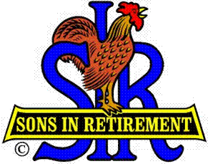

Las Trampas Branch 116

Luncheon Meeting Agenda

November 20, 2017

11:30 AM
- Call to Order – Big Sir.
- Welcome
- Pledge of Allegiance.
- Invocation: Art Donaldson
- Introduce Head Table
- Little Sir: Marty Katz
- Guest Speaker – Jim Darby
- Introduce Guests & Visitors
- Guests:
- Past Big SIRS – see list
- Visitors:
- Introduce New Members (if any)
- Big Sir Comment
- Recognize Military Veterans
- Senior SIR Awards
- Storyteller – Paul Ramacciotti

11:45 PM – Lunch
- Raffle Drawing
- Sunshine Report

12:15 PM
- Committee Reports

12:30 PM
Little Sir:
- Introduce Guest Speaker – Jim Darby – Muzuno/Easton Sports.
- Ask November Birthday guys to stand / sing Happy Birthday (Paul King & Robbie)
- Sign God Bless America.

